Q. Describe the two main roles of an operating system, and elaborate why these roles are important.
Q. What is the purpose of a trap table in an operating system? What does it contain? When is it consulted? When is it loaded?
Q. Context switching between two threads of execution within the operating system is usually performed by a small assembly language function. In general terms, what does this small function do internally?
Q. In contrast to MLFQ, Completely Fair Scheduler (CFS) in linux doesn't use any heuristics to identify interactive tasks rather it just makes sure every process gets a fair share of CPU within a set amount of time given the number of runnable processes on the CPU. Briefly state some key ideas by which CFS achieves this objective.
Q. Consider the following code and answer the questions:
int main(void) {
pid_t pid = -1;
for(int i=0; i<4; i++){
pid = fork();
if(pid != 0){
break;
}
}
waitpid(pid, NULL, 0);
printf(" %d, %d, %d \n", getpid(), pid, &pid);
return 0;
}
- Draw the shape (illustration) of process hierarchy that this code produces clearly indicating different processes and their relationship by appropriate name/IDs.
- What are the values printed by each process? Will they be same or different?
- Will the order of printing be consistent or arbitrary? Why?

Q. Consider the set of 6 processes whose arrival time and burst time are given below. (Can consider introducing IO in between as well)
Process Id | Arrival time | Burst time
P1 | 5 | 5
P2 | 4 | 6
P3 | 3 | 7
P4 | 1 | 9
P5 | 2 | 2
P6 | 6 | 3

If the CPU scheduling policy is Round Robin with time quantum = 3, calculate the average waiting time and average turn around time.
Solution :
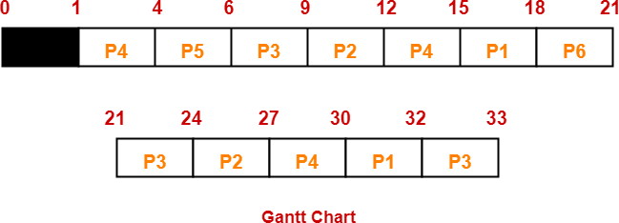
Ready Queue : P3, P1, P4, P2, P3, P6, P1, P4, P2, P3, P5, P4
Now, we know-
- Turn Around time = Exit time – Arrival time
- Waiting time = Turn Around time – Burst time

Process Id | Exit time | Turn Around time | Waiting time
P1 | 32 | 32 – 5 = 27 | 27 – 5 = 22
P2 | 27 | 27 – 4 = 23 | 23 – 6 = 17
P3 | 33 | 33 – 3 = 30 | 30 – 7 = 23
P4 | 30 | 30 – 1 = 29 | 29 – 9 = 20
P5 | 6 | 6 – 2 = 4 | 4 – 2 = 2
P6 | 21 | 21 – 6 = 15 | 15 – 3 = 12

Now,
- Average Turn Around time = (27 + 23 + 30 + 29 + 4 + 15) / 6 = 128 / 6 = 21.33 unit

Q. Given a 3-level MLFQ scheduler with a quantum length of 2 ms, 4ms, 6ms in its highest, middle and lowest queue respectively.
a) Why and when might a process be moved from a queue with short time slice to a longer time slice?
b) How often would you have to boost jobs back to the highest priority level to guarantee that a single long-running (and potentially starving) job gets at least 20% of the CPU, assuming there are not too many processes competing for CPU?
c) Let say the priority boost happen every 8 ms and 3 jobs arrive together in the order A, B & C with job length of 6, 20 and 10 respectively. When the priority boost fires, the current job is pre-empted and the next scheduled job is run in round-robin order. Draw the scheduling in the below graph (as discussed in class) showing the vertical lines for key events and clearly labelling the X-axis times.
